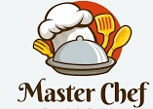 Best Chef Cafe

123 Main Street, City

Tax No: 123456789

TP: (123) 456-7890